A Homage to the French Geometers Gergonne and Monge

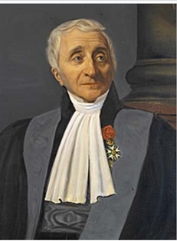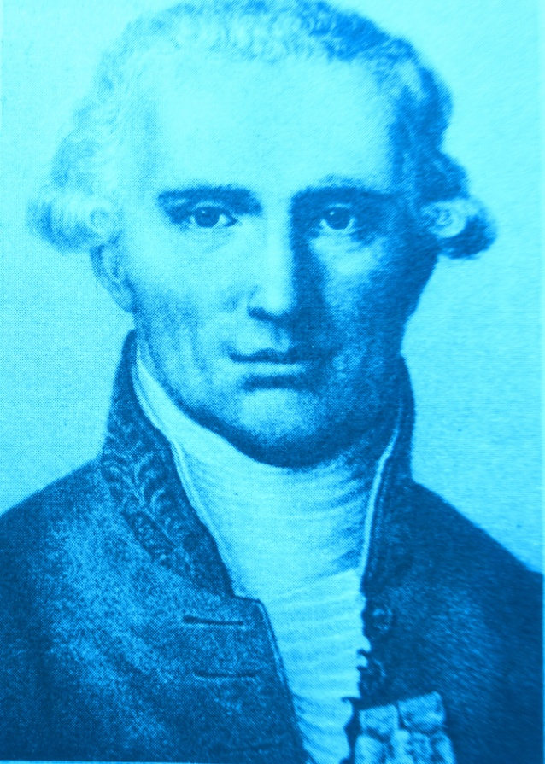

>> What the French contributed to triangle geometry <<

Udo Rehle, June 1926

The well-known intersection points of transversals are the centroid (medians) and the incenter (angle bisectors).
Yet the Gergonne point, the Gergonne triangle, or the >>Annales de Gergonne<< published in 1810 are unknown to almost everyone who attended a higher school. And the Lemoine point (symmedians), or the point of Monge, who founded the famous >>Ecole Polytechnique<< in Paris, is scarcely known either.
One cannot even pronounce their names correctly without knowing that they are French. And yet our neighbors - the French - have achieved so very much in mathematics, especially in triangle geometry! As a reminder, I will name only a few people whom everyone should know: Pierre Fermat, Rene Descartes, Blaise Pascal, Jean-Victor Poincare, Emile Lemoine, and Henri BROCARD ...

Here are their lifetimes
Rene Descartes 1596 - 1650
Pierre (de) Fermat 1601 - 1665
Blaise Pascal 1623 - 1662
( Jean-Baptiste le Rond d Alembert 1717-1783 )
( Joseph-Louis LAGRANGE 1736 - 1813 )
Gaspar Monge * 9 May 1746 in Baume - + 28 July 1818 in Paris
( Pierre-Simon LAPLACE 1749 - 1827 )
Joseph Diez Gergonne * 19 June 1771, Nancy - + 4 May 1859, Montpellier
Jean-Victor PONCELET 1788 - 1876
Emile Lemoine * 22 November 1840 in Quimper - + 21 February 1912 in Paris
Pierre Rene Jean Baptiste Henri BROCARD * 12 May 1845, Vignot - + 16 January 1922, Bar-le-Duc
Henri Poincare 1854 - 1912
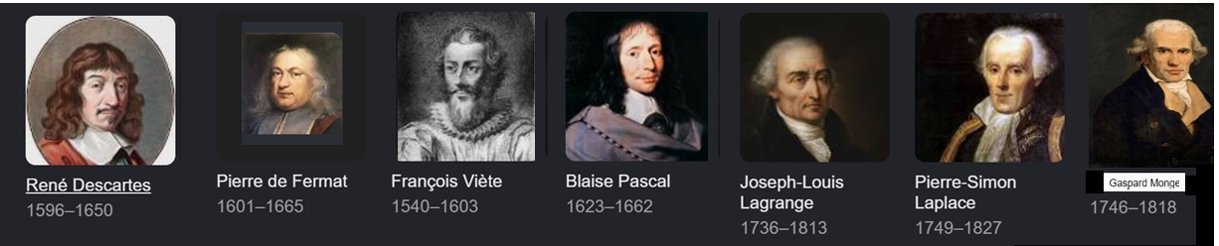

Another intersection point of three cevians is the Gergonne point!
The three contact points of the incircle form the so-called Gergonne triangle (sometimes also called the contact or intouch triangle). The cevians from the vertices to the opposite contact points meet in one point, the Gergonne point (Ge point for short)!
As an example, take the standard triangle with side lengths 3, 4, and 5. The center of the incircle with radius 1 is Mi = (1, 1).

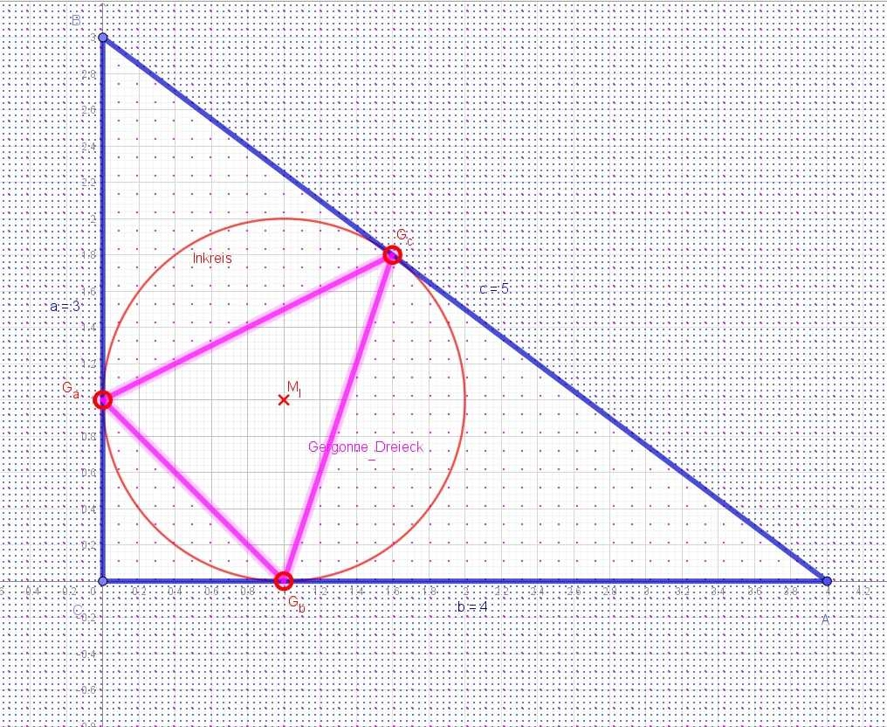
The standard right triangle with incircle, incenter Mi with radius r = 1, and Gergonne triangle (pink)
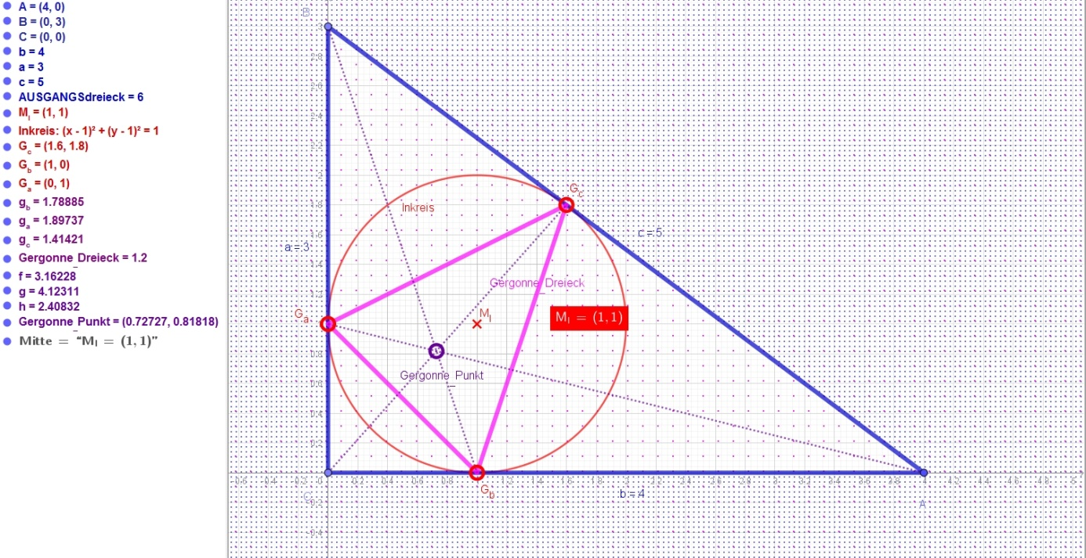
The Gergonne point is the intersection of the three lines from the vertices to the contact points; here it has coordinates (7/11; 8/11).

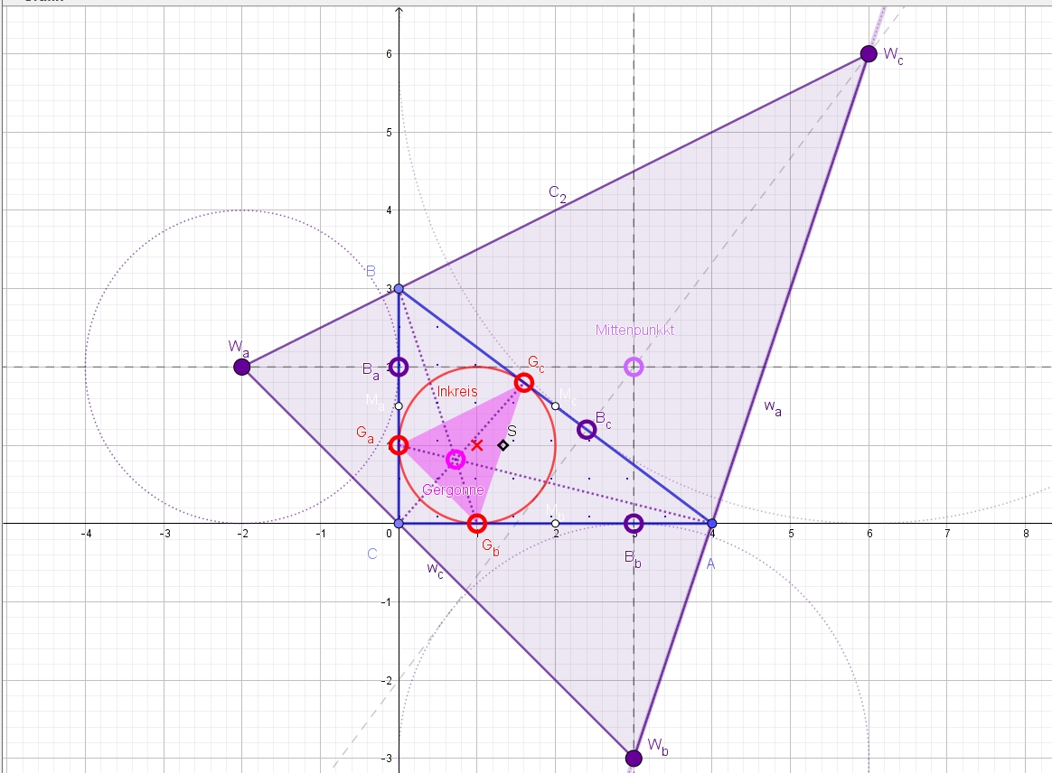
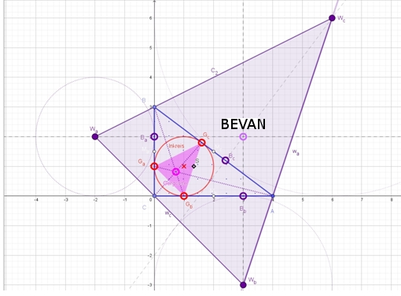
Symmetric to the side midpoints (white) lie the excircle contact points (purple). The triangle of the centers of the three excircles touching the sides externally (purple) is similar to the Gergonne triangle (pink). The similarity factor is k = 2R/r^2; here the circumradius is R = 1/2 c = 2.5 and r = 1.
The three perpendiculars to the sides of the triangle passing through the respective excenters also meet in one point, the BEVAN point. It is the center of the circle that passes through all excenters.
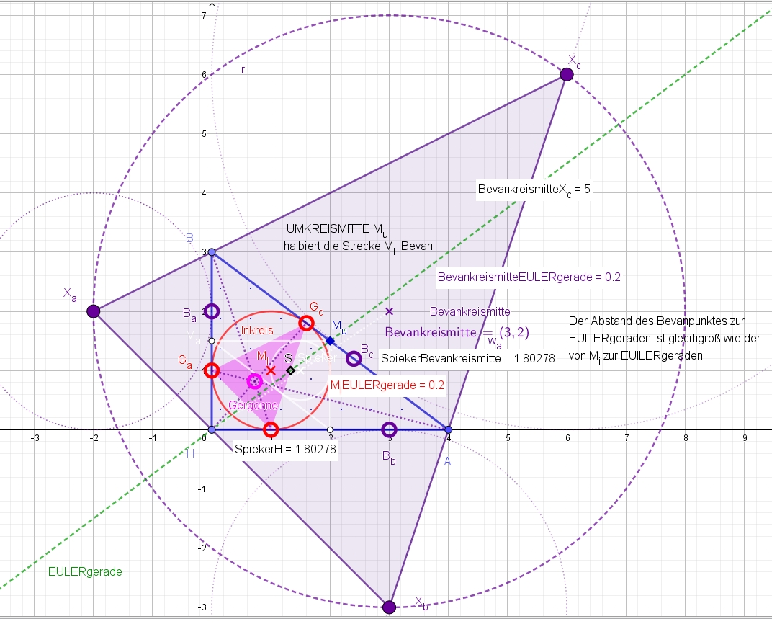
The centers Xi of the three excircles form a triangle whose circumcircle is the BEVAN circle. Its center is the Bevan point, and its radius is 2R (twice as large as the circumradius). The circumcenter Mu bisects the segment from the incenter Mi to the Bevan point. The midpoint of the segment joining the orthocenter H (here the right-hand vertex) to the Bevan point is bisected by the Spieker point, which is obtained by centrally dilating Mi about the centroid S with k = -1/2. It is the center of the incircle of the medial triangle (white). The Bevan point has the same distance from the EULER line (green) as the incenter Mi. The segments joining the excenters Xi to the Bevan point are perpendicular to the respective sides of the triangle.
The three connecting lines from the excenters Wi to the nearest side midpoints of the triangle (white) are also concurrent, i.e. they likewise meet in a point, the Mittenpunkt.

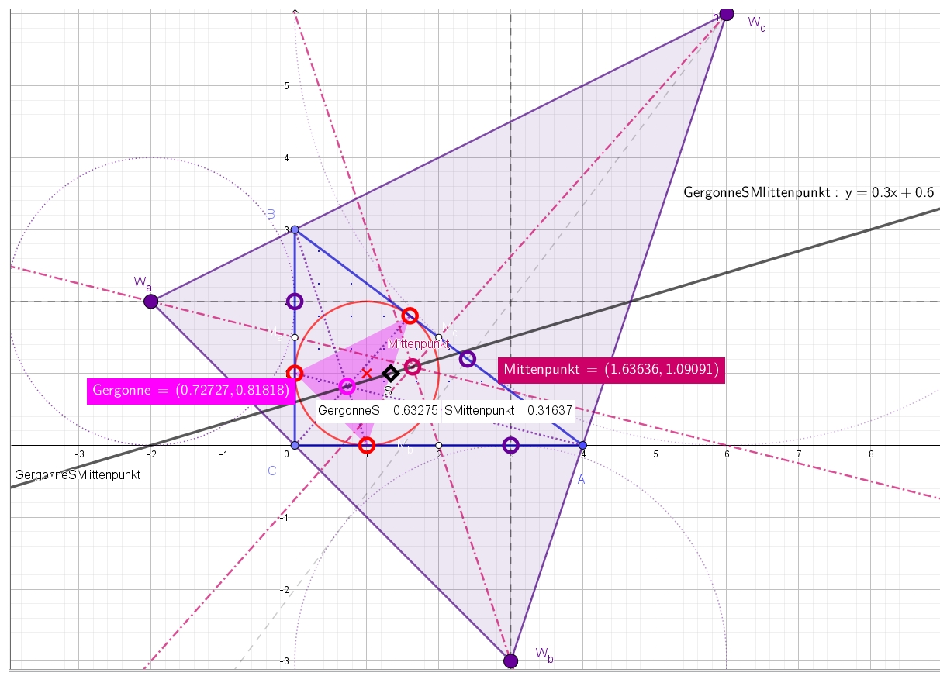
The Mittenpunkt, the centroid S, and the Gergonne point lie on one line. I would like to call the line on which they lie the Gergonne line, because GeS, analogous to the EULER line MuS and to the Nagel line NagelS, has this typical >>two-to-one division<< by the centroid. However, another line is already called the Gergonne line (see the next figure).

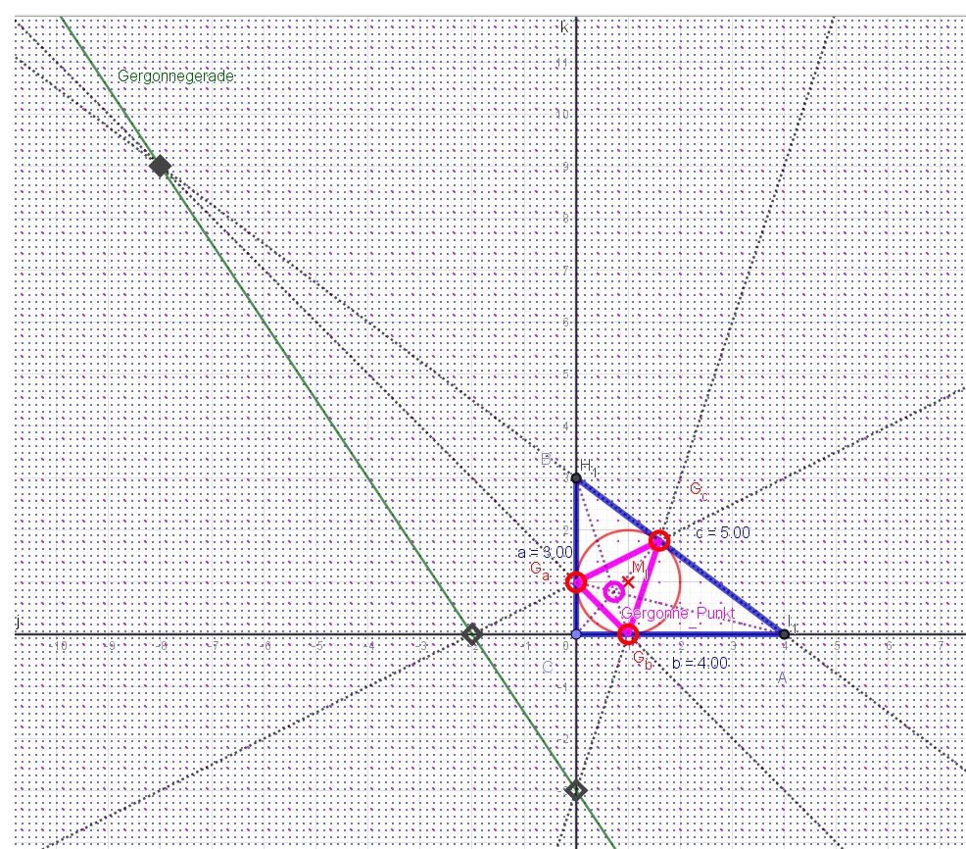
The original triangle and the Gergonne triangle are perspective.
Let us now place the incircle center Mi at the origin!
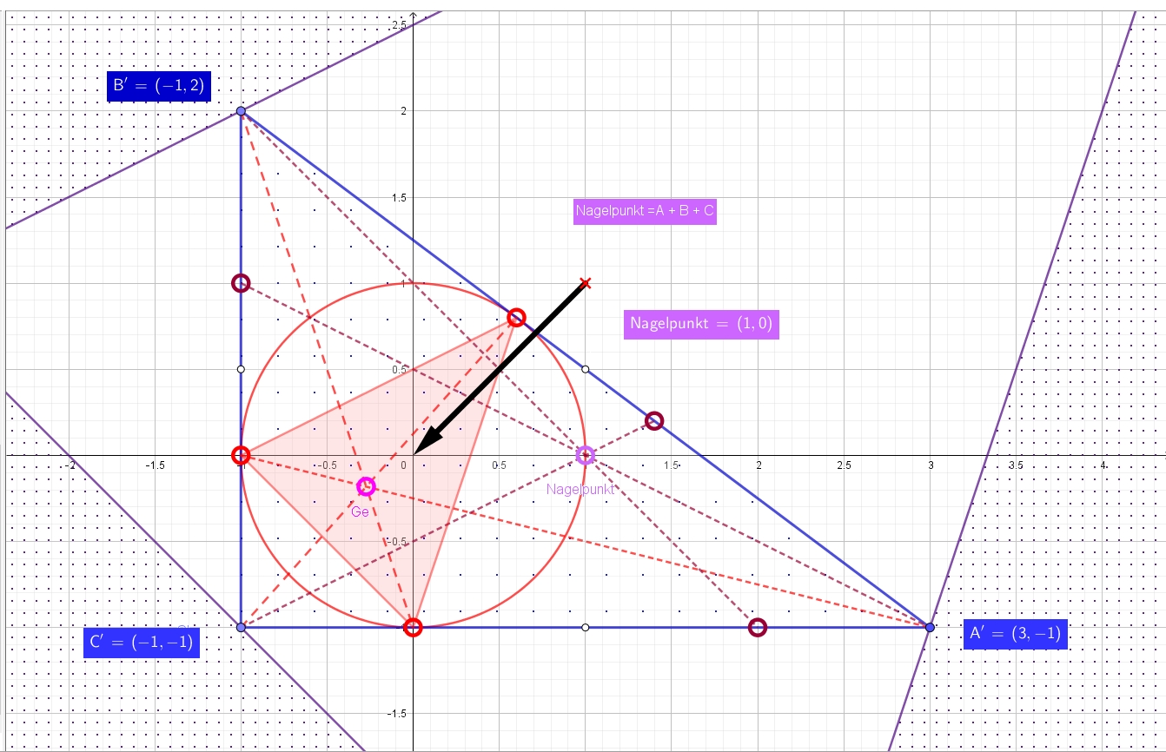

If we connect the excircle contact points (purple) with the opposite vertices of the triangle, these three lines meet - similarly to the Gergonne point - in one point, the Nagel point, named after Christian Nagel (1803-1882).
This is the point isotomically conjugate to the Gergonne point.
And if we place the incenter Mi at the origin (black vector), then the Nagel point is simply the sum of all three triangle vertices A + B + C!

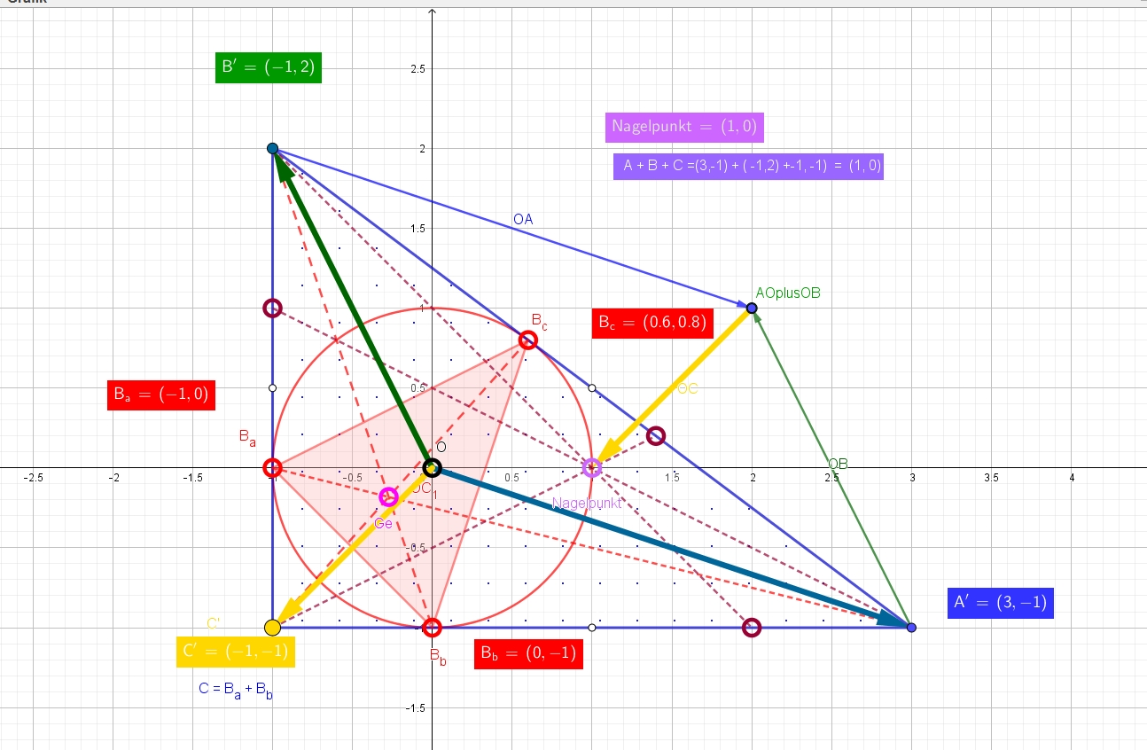
In general, the Nagel point therefore has the coordinates
Nagel = A + B + C - 2Mi
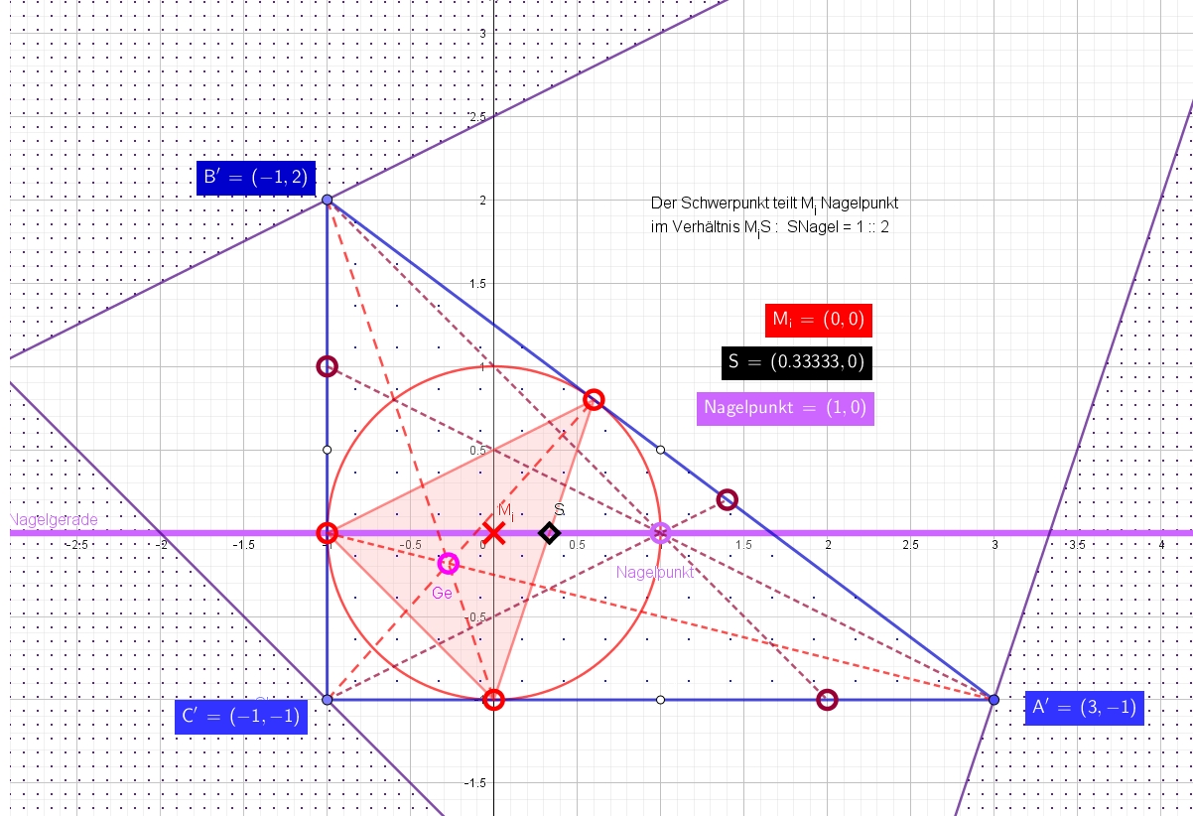
If we place the Nagel point at the origin, we obtain the Gergonne point as the vertex sum A + B + C
*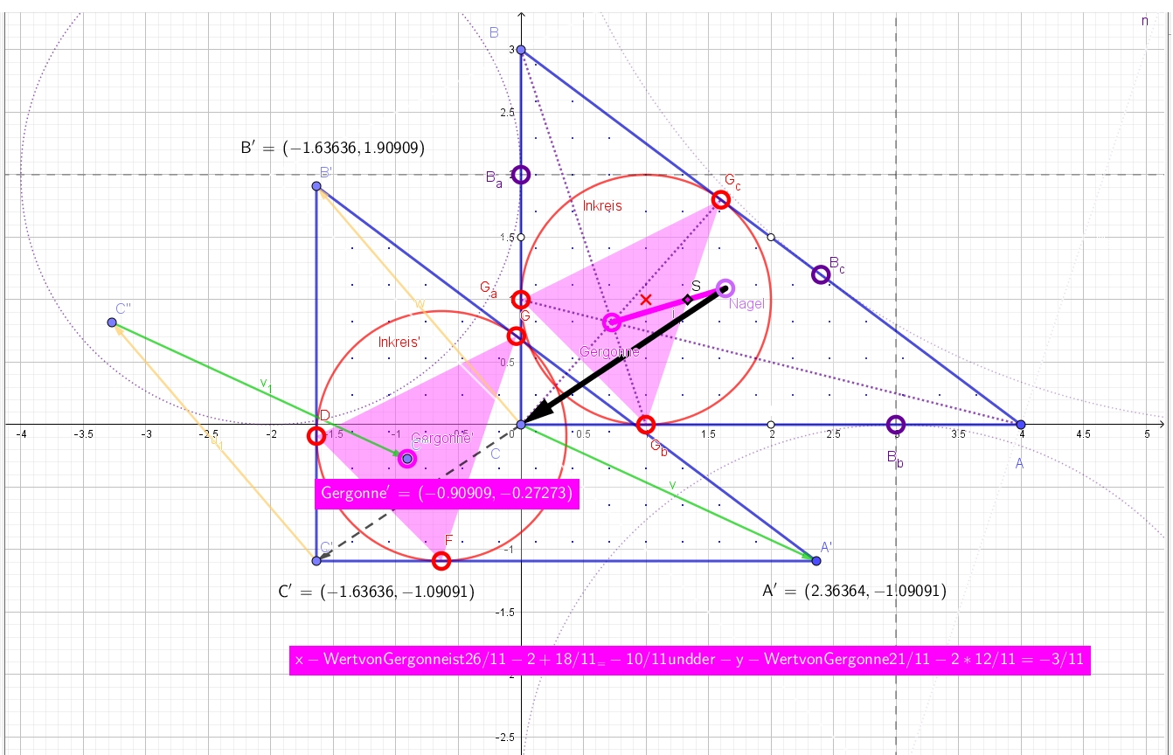
Thus the Gergonne point is A + B + C - 2*Nagel point
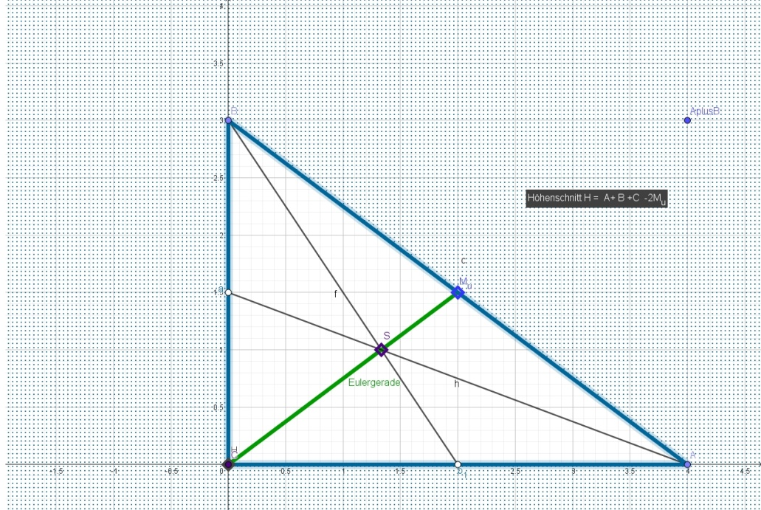
On the Euler line MuS, the orthocenter H also lies between them in such a way that HS = 2SMu.
Correspondingly, the orthocenter is H = A + B + C - 2Mu.
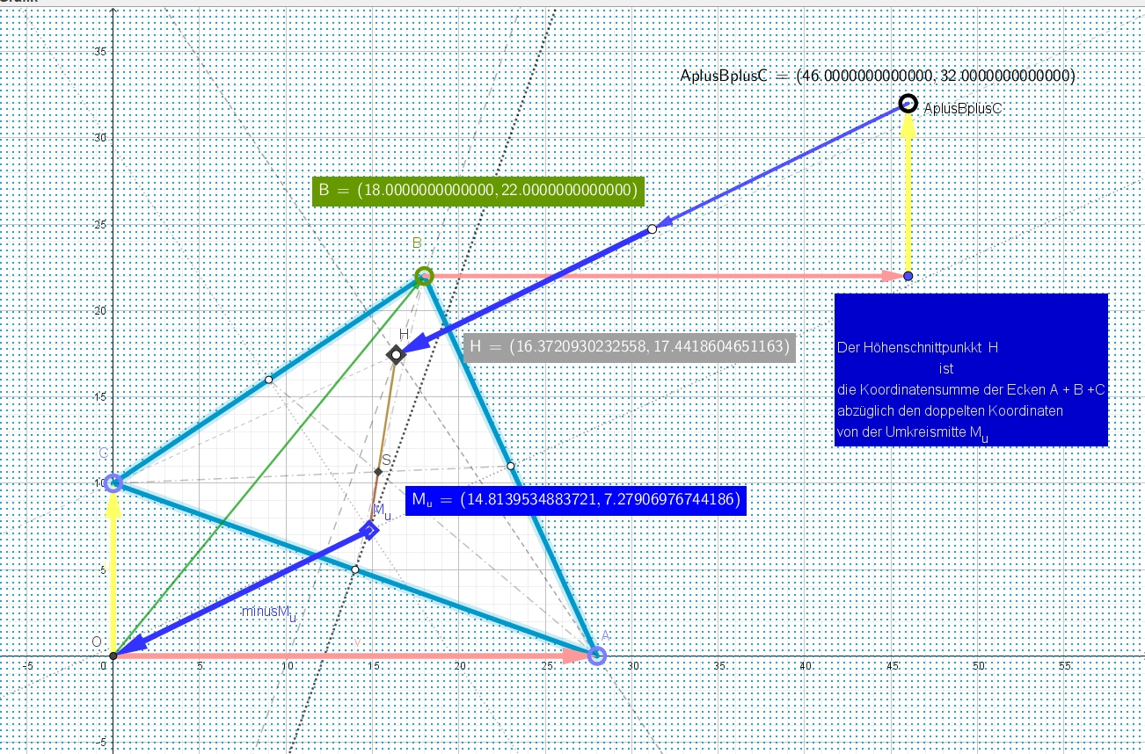

The Euler line MuS exists not only in plane geometry but also in three-dimensional space, as the revolutionary Gaspar Monge found. There, however, the body altitudes sometimes do not meet in a point at all. In that case one must replace it by the Monge point. But the ratios MongeS to SMu are no longer two to one; they depend on the dimension. For n = 3 they are one to one, if I remember correctly!
A spatial Gergonne and Nagel point also seem to exist - though probably only for various triangular pyramids. However, the geometry of 3D space is already much more difficult to handle, so I will not go into it further here.

Instead, let us explicitly compute the Gergonne point!

Calculation of the special triangle points

The special points of a triangle can also be calculated exactly!
The centroid is easiest to calculate as the arithmetic mean of the vertices:
S = 1/3 (A + B + C)

The incenter Mi is also still easy to calculate as the
average of the vertices weighted by the side lengths:

Mi = {|a|A + |b|B + |c|C}/u
where u = |a| + |b| + |c| is the perimeter.

For the right-angled case it follows that
Mi = (ab + ba i) /u = 2A(1+i)/u = r(1+i)
It is then considerably simpler to write the incenter as
Mi = r + ir

and the incenter forms a square with the right-angled vertex C!
We obtain the inradius from r = 1/2(a+b-c).

Example: If the legs are 9 and 40, then the hypotenuse is c = sqrt(9^2 + 40^2) = 41.
2r = 9 + 40 - 41 = 8, so the inradius is 4.
and the center of the incircle is
Mi = 4 + 4i
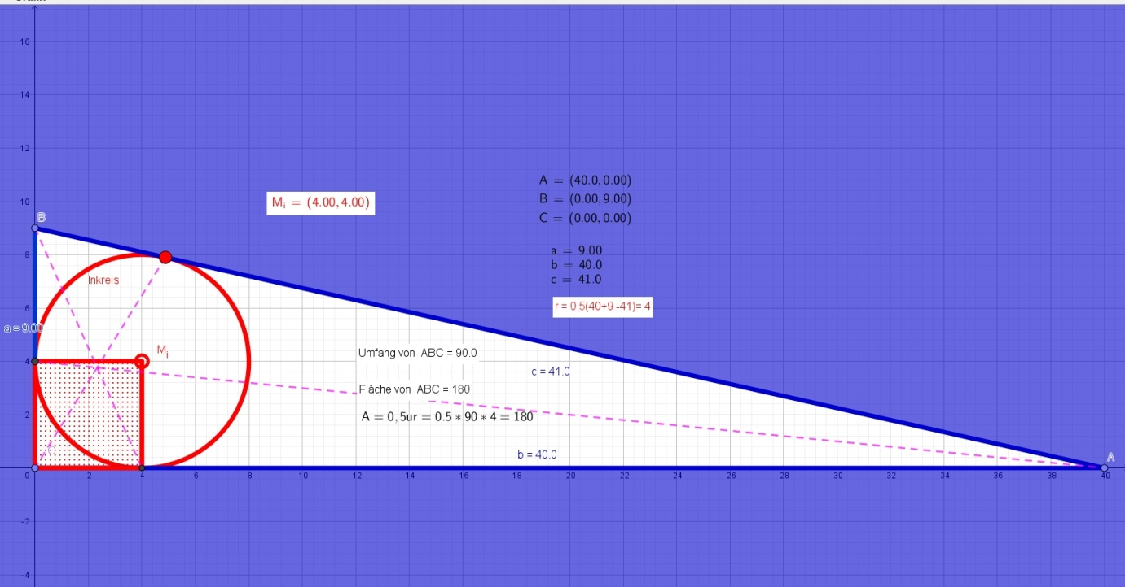

With s = 1/2u = 1/2(a+b+c)
the tangent, or tangential, segments x, y, and z are
1/2(ai + aj - ak)
so, for example, the smallest one (when c is the hypotenuse) is
x = 1/2(a+b-c)
therefore (s-ai) = xi
Example for side lengths 13, 14, and 15
s = (15+13+14)/2 = 21
s-a = 21-15 = 6 = x, etc.; y = 7, z = 8
abc = 4Ar or product xi = Ar
6*7*8 = 42*8 = 84*4 = Ar
The Gergonne point is relatively difficult to compute (here in complex form):

The Gergonne point is

G = xyz [ A / {ax^2 + Ar}
+ B / {by^2 + Ar}
+ C / {cz^2 + Ar}]

If vertex A is placed at the origin, then A = (0; 0)
(but not the area A)
and the formula simplifies to

G = Ar[ B / {by^2 + Ar} + C / {cz^2 + Ar}]

Example: a = 13, b = 15 and c = 4, with x = 3, y = 1 and z = 12

Gergonne = 36 * [4/(15*1^2+36) + (9+12i)/(4*12^2+36)]
Imaginary part: 36 * 12i / 612 = 36i/51 = 12i/17 = 0.70588...i
Real part 1 = 36[4 / {15+36}] = 12*4/17 = 48/17 ~= 2.82349...
Real part 2 = 36/68 = 9/17 ~= 0.5294...
The total real part is 57/17 ~= 3.35294...
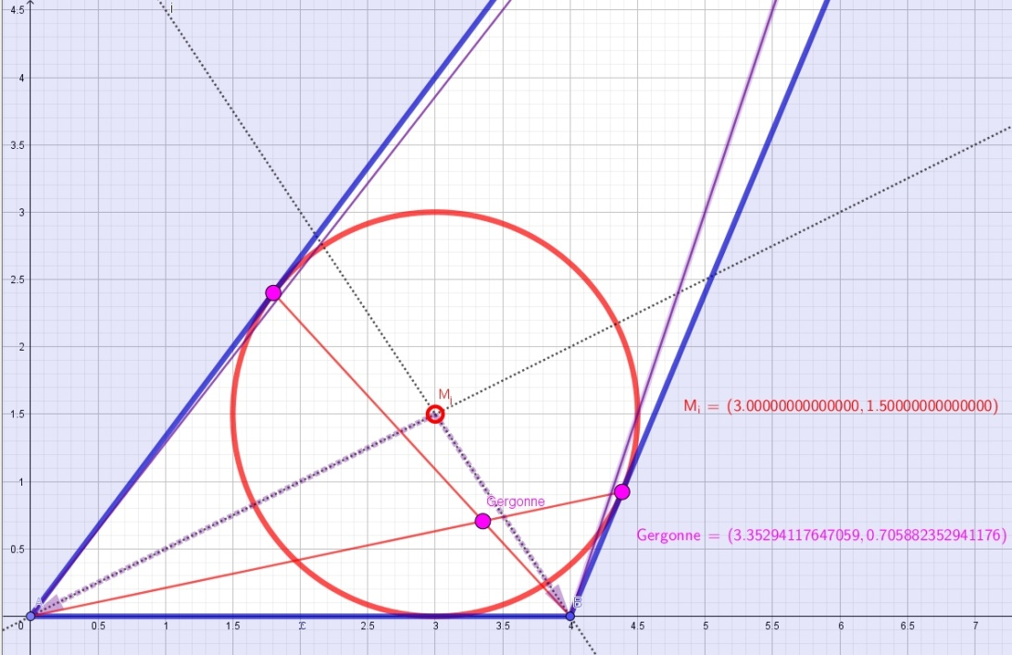

With A = (ax; 0) and B = (0; by), i.e. A = b and B = ia,
and C = (0;0) = (0+0i) = 0, the formula becomes a little simpler.

For C = origin and real B, we then obtain
Gergonne = Ar[ b /(ax^2+Ar) + ia /(by^2+Ar)]

where Ar = 1/2abr, A = 1/2ur = 1/4u(a+b-c), hence Ar = 1/2uz
(the product of the area and the inradius r = 1/2(a+b-c); a and b are the leg lengths; c is the hypotenuse)

and with the cyclically permuted tangential segments of
r = 1/2(a+b-c),
x = 1/2(b+c-a) and y = 1/2(c+a-b)

Example: a = 9, b = 40 and c = 41, Ar = 720
Gergonne = 720[ 40 /(9*36^2+720) + i9 /(40*25+720)]
= 720[40/12384 + i9/1720]
= 2.32558 + 3.76744186i

The segment from the Gergonne point to the Nagel point is parallel to the segment from the Mittenpunkt to Mi and exactly twice as long.
(The Nagel line intersects the line through the Gergonne point and the Mittenpunkt at the centroid S -> second intercept theorem.)
The distance Gergonne-Nagel =
GerNa = 4 sum ai^2 sqrt[{r - a^2b/(2c^2)}^2 + {r - ab^2/(2c^2)}^2] / {4r(u-r)}

For the points of minimal distance to the sides, one has
Ln = [a^(n/(n-1)) A + b^(n/(n-1)) B + c^(n/(n-1)) C] / [a^(n/(n-1)) + b^(n/(n-1)) + c^(n/(n-1))]

In particular, for n = 2 we obtain the Lemoine (symmedian) point

L = [a^2 A + b^2 B + c^2 C] / [a^2 + b^2 + c^2]

In our right-angled case with C = 0, A = b and B = ia, it follows (in this case for the midpoint of the altitude)

L = [a^2 b + b^2 ai] / [a^2 + b^2 + c^2]
= ab[a + bi] / sum ai^2

Example: a = 9, b = 40 and c = 41, Ar = 720, u = 90

Since a^2 + b^2 + c^2 = 3362, we obtain
L = 9*40[9 + 40i] /3362 = 1620/1681 + i 7200/1681
= 0.963712... + 4.28316... i

Let us compute the distance from the Lemoine point to the incenter.
|L Mi| = | r + ri - ab/sum ai^2 [a+bi] |
= sqrt[(r - a^2b/sum ai^2)^2 + (r - ab^2/sum ai^2)^2]

In our example this becomes
(0.963712...-4)^2 + (4.28316-4)^2 = 9.299175824
And the distance from the Lemoine point to Mi is
the square root of this, namely 3.049456...
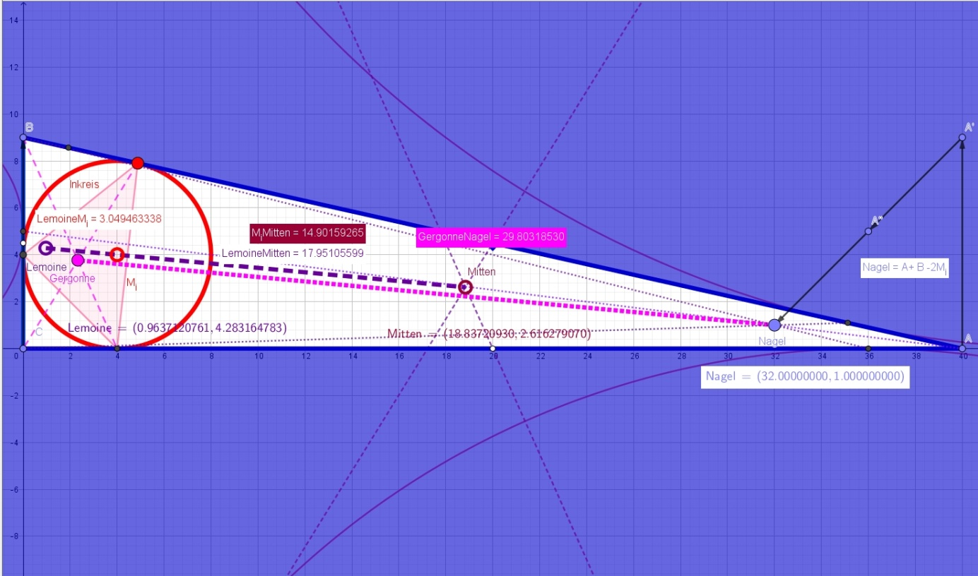
The incenter Mi, the Mittenpunkt, and the Lemoine point L lie on one line.
Also collinear are
Mittenpunkt, S, and Gergonne point
Nagel point, Mi, S, and Spieker point
Mittenpunkt, H, and Spieker point

The Gergonne point (intersection of the three transversals from the vertices to the incircle contact points) is the Lemoine point of the Gergonne triangle formed by the incircle contact points.
Until 1832, Jean-Victor Poncelet, Michel Chasles, Jakob Steiner, Julius Plucker, and Evariste Galois, among others, published there.
Emile Michel Hyacinthe Lemoine (* 22 November 1840 in Quimper, France; + 21 February 1912 in Paris). The founder of modern triangle geometry is famous for discovering the Lemoine point and the Lemoine circles. >>Note sur les proprietes du centre des medianes antiparalleles dans un triangle<< later became one of his most famous works.
Earlier there were Francois Vieta (1540-1603) and Gerard DESARGUES (1591-1661).
(* 12 May 1845 in Vignot, canton of Commercy; + 16 January 1922 in Bar-le-Duc) is known for discovering the two Brocard points and circles of a triangle (triangle geometry is called >>geometrie Brocardienne<< in French).
Video note: Henri Poincare -- The forgotten giant behind Einstein's theory | Documentary www.youtube.com/watch?v=RsOmJovCvdM or https://youtu.be/RsOmJovCvdM
The Mittenpunkt is the Lemoine point (symmedians) of the excentral triangle.
HS : SMu = 2 : 1, or NaS : SMi = 2 : 1.
He published this in 1935/36. He also found the Mittenpunkt.
According to Ceva's theorem, these three lines meet because all division ratios on the segments of the triangle have simply been inverted.
The period after the French Revolution of 1789 in particular was a very fruitful time for mathematics and the sciences. Think only of the introduction of the meter as the forty-millionth part of the Earth's circumference, or of the >>Ecole Polytechnique<<, which Monge founded and directed. In 1818 he died very embittered, extremely poor, and lonely, because all offices and honors had been revoked after Napoleon's fall from power.
a^2 + b^2 + c^2 = 1/2u^2 - 2r(2R+r). The sum of the side squares is also 1/4u^2 (=2025) plus sum xi^2 (=1337).

